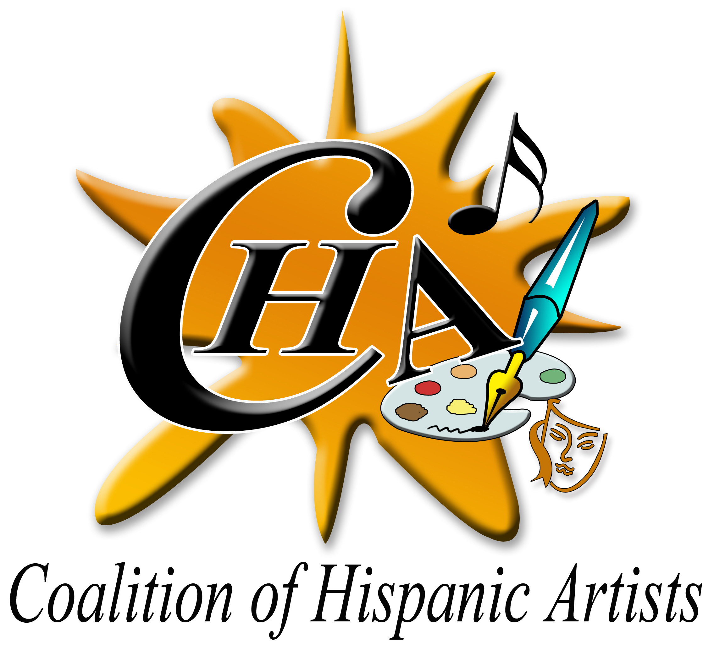 | COALITION OF HISPANIC ARTISTS, INC. (Aka C.H.A.)  Post Office Box 152324,Tampa, FL 33684-2324  Web http://artcha.org, mail.Cha.hispana@gmail.com  https://www.facebook.com/cha.migos.3/& https://www.facebook.com/1chamigo/ https://www.instagram.com › cha.hispana  Phone No. (813)300-1635  MEMBERSHIP APPLICATION  Artistic Category:  Poetry/Writing  Performance (specify)______________,   Music,  Sculpture,  Jewelry  Crafts,  Visual Fine Arts, Photography  Other (Specify)__________________

**Please complete in its entirety for full consideration fiscal calendar 2025/2026
Name

Street Address
City, State, and ZIP Code
Telephone No
Cellular No.
e-Mail Address
Country of Origin

From what source (e.g., word of mouth, article in print, etc) did you learn about C.H.A.?

What is your art form (e.g., painting, photography, sculpture, crafts, artisan, dance, poetry, playing musical instruments, etc.)?

Interests (Please tell us in which areas you are interested in volunteering?)
___Administration/Clerical | ___Public relation Committee
___Events/Programs | ___ Social Media (Website, Instagram, Facebook, YouTube)
___Secretary/Treasurer | ___Newsletter production
___Fundraising | ___Communications
___Board Member  ___Education committee | ___ A Committee  ___Performer arts Committee  ___ Literary and editing Committee
____ Marketing (e.g., soliciting  advertisers, donors, patrons) | ____Graphics / promotional, materials/video production & Photography.  Other (special skills/qualifications can you bring to CHA?): __________________  _____________________________

Agreement and Signature

I affirm that the facts set forth on this application are true and complete. I understand that if I am accepted as a member, any false statements, omissions, or other misrepresentations made by me on this application may result in the loss of my eligibility for membership in the Coalition of Hispanic Artists. *Due date of renewal is on the anniversary date of this application.

Signature Date

Individual - $50.00  Couples - $80.
→ Seniors $25. Student$35 (18-21 years of age) -  Corporate - $200.

PayPal , ZELLE,Or Credit Card Payment Information American Express,  Discovery,  Master Card,  Visa Credit Card No. ________________________ Exp. Date____/___/___ 3# Bar Code Card__________, visit https://www.artcha.org/donations/ or , Money Order, Check payable to C.H.A.:

Mail application to:

Coalition of Hispanic Artists
Post Office Box 152324
Tampa, FL 33684- 2324

C.H.A., c/o Membership
For additional information, contact
Cha.hispana@gmail.com copy to Magdalena Matias Negron, Secretary, Ph. (813)300-1635 E-mail magdalena.matias49@yahoo.com

Thank you for completing this application form and your interest in joining us. Please e-mail and 200 words Biography (word document) and your picture jpg format to Magdalena Matias Negron, Secretary Ph. 813-300-1635 E-mail:magdalena.matias49@yahoo.com
and copy to E-mail: Cha.hispana@gmail.com

Note: The Coalition of Hispanic Artists, Inc. Dues shall be paid in February 1st. of each year. Only new members can enroll any time. A new member is considered a first-time member or a returning member after three (3) years absent from C.H.A. Up-dated 05/2025

Coalition of Hispanic Artists (CHA) is a 501 © (3) nonprofit organization founded in April 2007 and incorporated in March 2008, is formed of a volunteer board of directors of different nationalities.
Mission Statement.
CHA’ s mission is to provide Hispanic Artists a secure cultural environment for development and to provide them an opportunity to exhibit and promote their talents to be appreciated and enjoyed by the Tampa Bay community and other art admirers, while educating the public about the history, culture, and diversity of Hispanic art.

MOTTO: Celebrating the Diversity of Hispanic Artistry and Providing Access to All

To learn more about CHA and its various artists and activities go to https://artcha.org, Cha.hispana@gmail.com
https://www.instagram.com › cha.hispana, https://www.facebook.com › cha.migos.3
Post Office Box 152324, Tampa, FL 33684-2324

